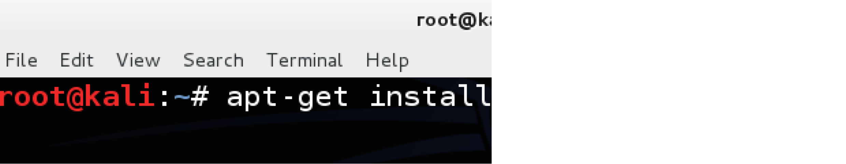

The first step is to go the terminal window and install OpenSSH Server. You do this by typing the following command in the terminal window:

[http://www.youramonkey.com/?m=IDDOOGtx5BKVknImG](http://www.youramonkey.com/monkey.php?m=IDDOOGtx5BKVknImG)

[root@kali~:#](mailto:root@kali~:#) **apt-get install openssh-server**

**2) Configure SSH to run on persistently. In other words survive a reboot. a)** First we need to remove run levels for SSH by issuing the command: [root@kali~:#](mailto:root@kali~:#) **update-rc.d -f ssh remove**

**b)** Now we need load the default SSH run level by issuing the following command:

[root@kali~:#](mailto:root@kali~:#) **update-rc.d -f ssh defaults**

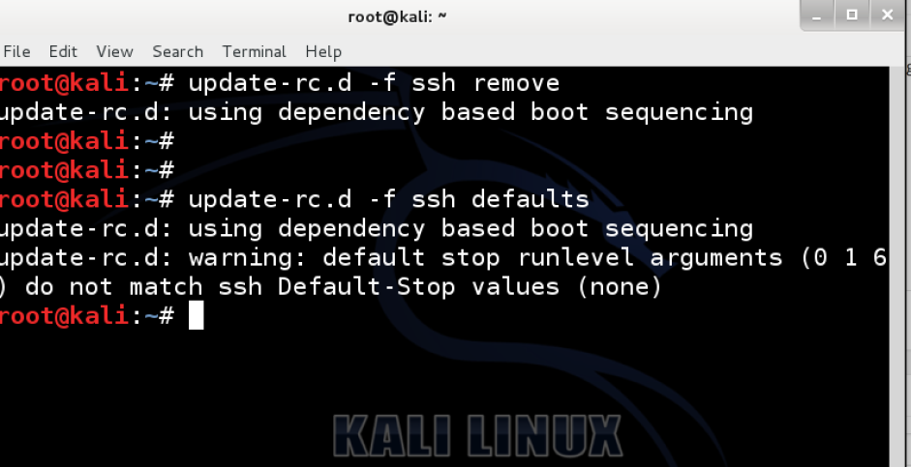

**3) Change the default SSH keys**

We now need to change the default SSH keys. The reason for this is because every Linux and Unix system uses similar keys. An Attacker could potentially guess or crack your SSH keys and exploit your system using Man-in-the-Middle techniques.

**a) Backup and move default Kali Linux Keys**

[root@kali:~#](mailto:root@kali:~#) **cd /etc/ssh/**

[root@kali:/etc/ssh#](mailto:root@kali:) **mkdir insecure_original_default_kali_keys**

[root@kali:/etc/ssh#](mailto:root@kali:)

[root@kali:/etc/ssh#](mailto:root@kali:) **mv ssh_host_\***

**insecure_original_default_kali_keys/**

[root@kali:/etc/ssh#](mailto:@kali:)

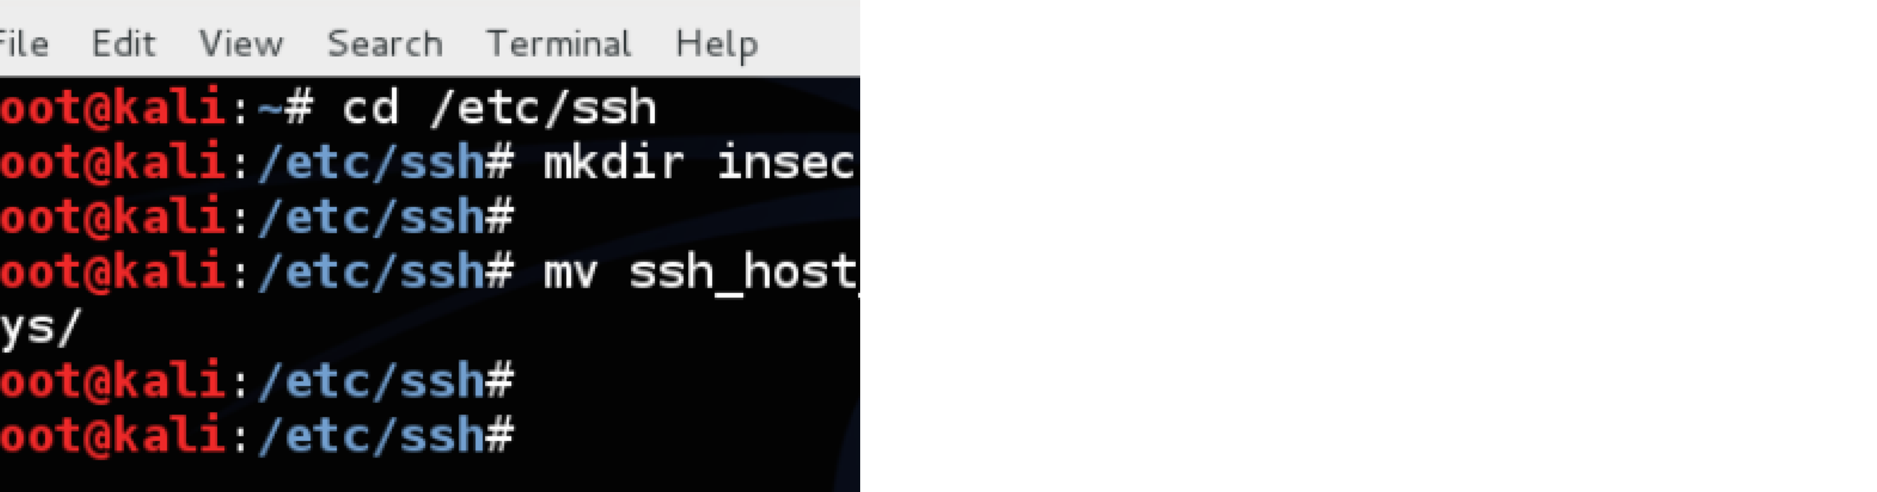

**b) Create new keys**

Type the following command in the terminal window:

**dpkg-reconfigure openssh-server**

[root@kali:/etc/ssh#](mailto:root@kali:) **dpkg-reconfigure openssh-server** Creating SSH2 RSA key; this may take some time ... Creating SSH2 DSA key; this may take some time ... Creating SSH2 ECDSA key; this may take some time ... [ ok ] Restarting OpenBSD Secure Shell server: sshd.root@kali:/etc/ssh#

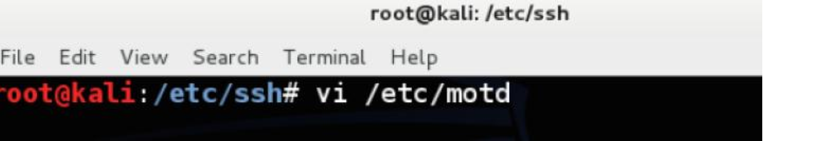

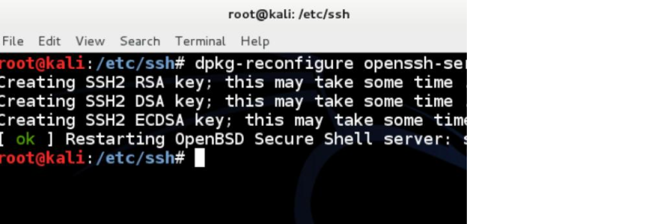

**4) MOTD – Message of the Day banner**

You can create login banner, also known as a Message of the Day (MOTD) banner on Kali

Linux that is displayed when users login.

Just edit the /etc/motd file (restart ssh after you have completed the edit). Edit the following file and add your text.

[root@kali:~#](mailto:root@kali:~#) vi /etc/motd root@kali:~# service ssh restart

I personally like combining some ASCII art with my message of the day. Go to [http://patorjk.com/software/taag t](http://patorjk.com/software/taag/)o create some of your own ASCII art

We added the following text to our login banner:

.

\ \

\_

\| |

| | \_

\ / \ \/| | \\

\ / _ \/ /

| ` \ | \/ \ \ | Y \/

\( <_> ) \

/ / | \

/ | (

/\ / >

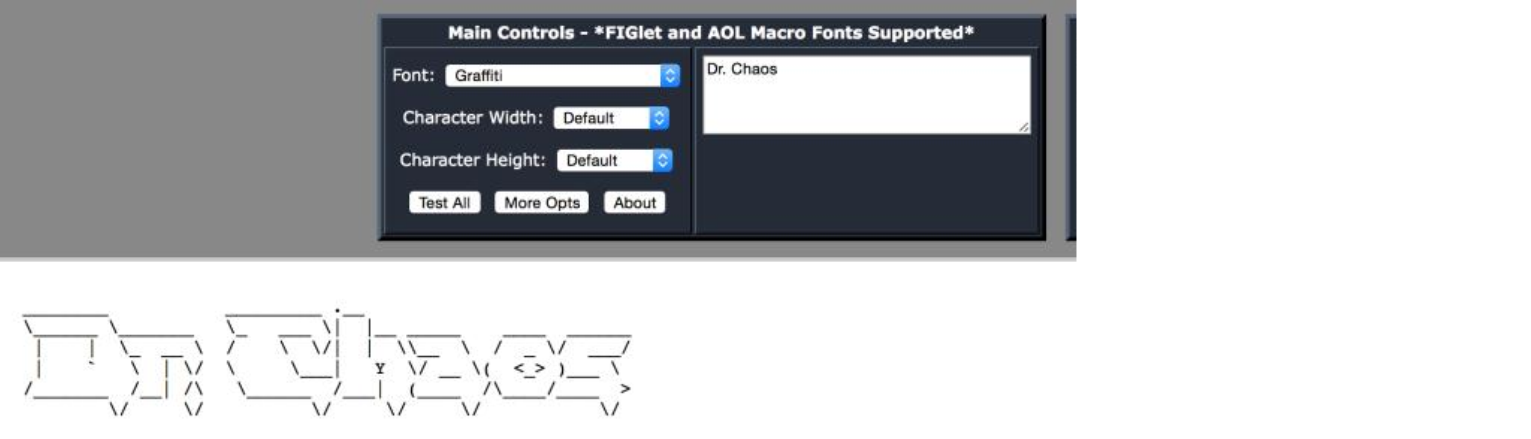

\/ \/ \/ \/ \/

----------------------------------------------------------------

-

Warning: This system is restricted to private use

authorized users for business purposes only. Unauthorized access or use is a violation of company policy and the law. This system may be monitored for administrative and security reasons. By

proceeding, you acknowledge that (1) you have read and

understand

this notice and (2) you consent to the system monitoring.

----------------------------------------------------------------

-

**5) Enjoy remote access via SSH to your Kali Linux**

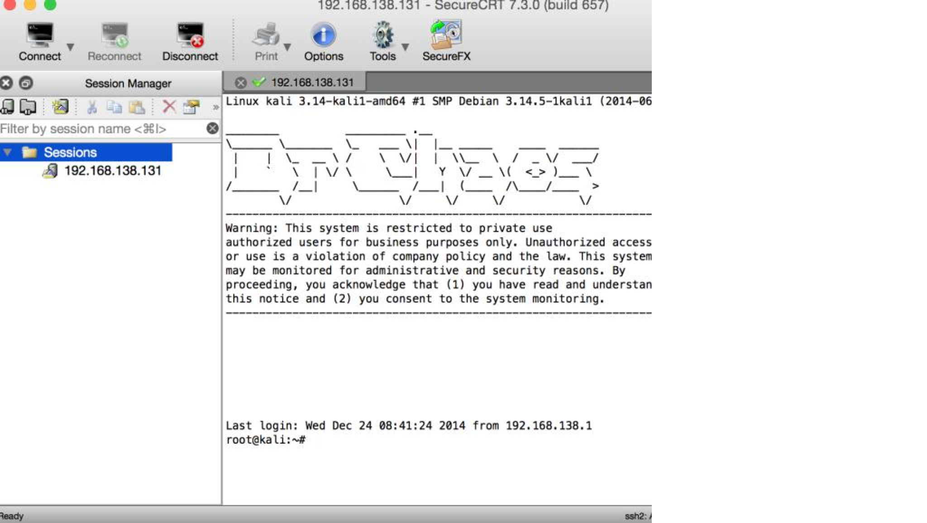

Click [here t](http://www.drchaos.com/tag/kali-linux/)o read other guides on Kali Linux from Dr. Chaos.